## DOI:<https://doi.org/10.63359/f5cava93>

Slope Instability, Landsliding and Hazards

Analysis at Highway Roadcut

Ahmed A. Mohammed, Farag Adam Ali & Ibrahim M. Abou El Leil

|  |  |  |
| --- | --- | --- |
| A R T I C L E I N F O  ***Vol. 7 No. 2 Agusust, 2025***  Pages (12- 26)  ***Article history:***  Revised form 07 May 2025  Accepted 21 June 2025  ***Authors affiliation***  *123Department of Geology, Faculty of Science, Tobruk University*    1ahmed.mohammed@tu.edu.ly  2faraj.admi@tu.edu.ly  3ibrahim.aboueleil@tu.edu.ly  ***Keywords:***  Slope instability; road cut; rock failure; landslides; hazards.  © 2025  Content on this article is an open access licensed under creative commons CC BY-NC 4. |  | **A B S T R A C T**  The stability of rock slopes is crucial to public safety in highways passing through rock cuts. Slope instability and failures occur due to many factors such as adverse slop geometries, geological discontinuities, weak or weathered slope materials as well as severe weather conditions. External loads like heavy precipitation and earthquakes could play a significant role in slope failure. The main objective of this study is to assessment the stability of rock slopes throughout the passing highway and hazard potentiality. In this paper, several rock mass classification systems for rock slope stability assessment were critically evaluated against known rock slope conditions in the northeastern region of Libya to includes two areas are Al Bakour area and Al Shaliony area that located east Benghazi city. The investigated rock formations in both areas are mainly formed of carbonate rocks that represented by chalk, limestone, dolomite in addition to the intercalated shale, with cliffs features of slope angle ranging from 70 to 90º. Also, these formation are highly topographic features and varies in thickness and extensions as well as structurally patterns. The stability conditions were identified and the stability of the rock cuts have been evaluated using different procedures e. g. determining the most relevant factors affecting slope instability; interpreting the discontinuity data collected from the surveys for the assessment of the modes of failure and determining the potential unstable zones. This study reveals that the cut needs to be mitigated because of the a few outcrops of rock slopes that covered by the metal mish not enough to support protection against rock collapse an failure ongoing slope instability present in some areas, that including planar and wedge slides and raveling rock falls. It was found that the unstable rock areas create serious safety hazards to traffic.  **تحليل عدم استقرار المنحدر والانهيارات الأرضية والمخاطر في شق الطريق السريع**    أحمد عبد الله محمد ، فرج آدم علي ،إبراهيم محمد أبو الليل    يُعد استقرار المنحدرات الصخرية أمرًا بالغ الأهمية للسلامة العامة في الطرق السريعة التي تمر عبر قطع الصخور. حيث يحدث عدم استقرار المنحدرات وانهيارها بسبب العديد من العوامل مثل هندسة المنحدرات المعاكسة، والانقطاعات الجيولوجية، وضعف مواد المنحدرات أو تآكلها، بالإضافة إلى الظروف الجوية القاسية. كما يمكن أن تلعب الأحمال الخارجية مثل الأمطار الغزيرة والزلازل دورًا مهمًا في انهيار المنحدر. إن الهدف الرئيسي من هذه الدراسة هو تقييم استقرار المنحدرات الصخرية على طول الطريق السريع المار واحتمالية المخاطر. ففي هذه الورقة العلمية، تم تقييم العديد من أنظمة تصنيف الكتل الصخرية لتقييم استقرار المنحدر الصخري بشكل حاسم مقابل ظروف المنحدر الصخري المعروفة في المنطقة الشمالية الشرقية من ليبيا، والتي تشمل منطقتين هما منطقة الباكور ومنطقة الشليوني الواقعة شرق مدينة بنغازي. حيث تتكون التكوينات الصخرية التي تمت دراستها في كلتا المنطقتين بشكل رئيسي من صخور الكربونات التي تمثلها الطباشير والحجر الجيري والدولوميت بالإضافة إلى الصخر الطفلة المتداخل، مع سمات المنحدرات التي تتراوح زاوية ميلها بين 70 و90 درجة. كما أن هذه التكوينات تتميز بخصائص طبوغرافية عالية وتتنوع في السُمك والامتدادات وكذلك الأنماط الهيكلية. لقد تم تحديد ظروف الاستقرار وتقييم استقرار القطع الصخري باستخدام إجراءات مختلفة، مثل تحديد أهم العوامل المؤثرة على عدم استقرار المنحدر؛ وتفسير بيانات الانقطاع التي جُمعت من المسوحات لتقييم أنماط الانهيار وتحديد مناطق عدم الاستقرار المحتملة. كما تكشف هذه الدراسة عن ضرورة تخفيف آثار القطع نظرًا لعدم كفاية بروز بعض المنحدرات الصخرية المغطاة بالشبكة المعدنية لدعم الحماية من انهيار الصخور وعدم استقرار المنحدر المستمر في بعض المناطق، بما في ذلك الانزلاقات المستوية والإسفينية وسقوط الصخور المتعرجة. وقد وُجد أن مناطق الصخور غير المستقرة تُشكل مخاطر سلامة جسيمة على حركة المرور. |

INTRODUCTION

***--------------------------------------------------------***

Slope failure represents an important form of geologic hazard. Identification of such features on a regional scale has been accelerated, in recent years, by various studies (Schulz, 2004, 2007; Burns and Madin, 2009). However, small-scale slope and bedrock failures present a different level for hazard study. Slopes present along roadways present a substantial hazard to drivers and expense and liability to roadway agencies. Such failures are dictated by a combination of factors such as bedrock character, steepness of slope, and climatic conditions. Because the study area has no single set of stratigraphic, structural, or topographic conditions that can be applied a certain approach for potential slope failure regimes. Thus, it is necessary to evaluate roadway exposures in different sites under a different set of observed and measured characteristics and constraints. Slope stability depends on the orientation of discontinuity in the rock mass. Slopes along the road cut may fail due to the presence of unevenly oriented discontinuities in the rock mass. Therefore, it is essential to evaluate unfavorably orientation of discontinuity (Park et al. 2016). Researchers around the globe have carried out various stability assessment using rock mass classification (Sardana et al. 2019; Sarkar et al. 2012), rockfall assessment(Verma et al. 2018; Vishal et al. 2017) and stability in soil slopes (Singh et al. 2018), stability of rock slopes using numerical modeling techniques (Verma et al. 2016, 2019; Pradhan et al. 2018; Kumar et al. 2017; Verma and Singh 2010) in the landslide-prone area. Some typical landslides which could affect residential housing are illustrated below:

**1.1. Rotational or Circular Slip Failures**

Can occur on moderate to very steep soil and weathered rock slopes as seen in Figure 1. The sliding surface of the moving mass tends to be deep seated. Tension cracks may open at the top of the slope and bulging may occur at the toe. The ground may move in discrete "steps" separated by long periods without movement. More rapid movement may occur after heavy rain (Table 1) (GeoGuide LR, 2007).

Table 1 - Slope (GeoGuide LR, 2007)

|  |  |  |  |
| --- | --- | --- | --- |
| Appearance | Slope  Angle | Maximum  Gradient | Slope Characteristics |
| Gentle | 0° - 10° | 1 on 6 | Easy walking. |
| Moderate | 10°- 18° | 1 on 3 | Walkable. Can drive and man oeuvre a car on driveway |
| Steep | 18°- 27° | 1 on 2 | Walkable with effort. Possible to drive straight up or down roughened concrete driveway, but cannot practically man oeuvre a car. |
| Very Steep | 27°- 45° | 1 on 1 | Can only climb slope by clutching at vegetation, rocks etc. |
| Extreme | 45°- 64° | 1 on 0.5 | Need rope access to climb slope |
| Cliff | 64°- 84° | 1 on 0.1 | Appears vertical. Can abseil down. |
| Vertical or Overhang | 84° - 90±° | Infinite | Appears to overhang. Abseiled likely to lose contact with the face. |

**1.2. Translational Slip Failures**

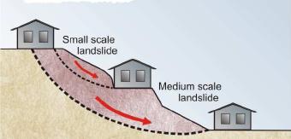Tend to occur on moderate to very steep slopes (Figure 2) where soil, or weak rock, overlies stronger strata. The sliding mass is often relatively shallow. It can move, or deform slowly (creep) over long periods of time. Extensive linear cracks and hummocks sometimes form along the contours. The sliding mass may accelerate after heavy rain (Table 1).

**Fig. (1): Rotational or circular slip failures**

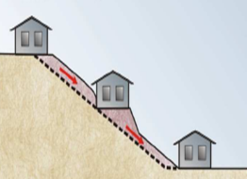

**Fig. (2): Translational slip failures**

**1.3. Wedge Failures**

Normally only occur on extreme slopes, or cliffs (Table 1), where discontinuities in the rock are inclined steeply downwards out of the face (Figure 3).

**1.4. Rock Falls**

Tend to occur from cliffs and overhangs as seen in Figure 3 and Table 1. Cliffs may remain apparently unchanged for hundreds of years. Collections of boulders at the foot of a cliff may indicate that rock falls are ongoing. Wedge failures and rock falls do not "creep". Familiarity with a particular local situation can instill a false sense of security since failure, when it occurs, is usually sudden and catastrophic.

**1.5. Debris Flows and Mud Slides**

May occur in the foothills of ranges, where erosion has formed valleys which slope down to the plains below (Figure 4). The valley bottoms are often lined with loose eroded material (debris) which can "flow" if it becomes saturated during and after heavy rain. Debris flows are likely to occur with little warning; they travel a long way and often involve large volumes of soil. The consequences can be devastating.

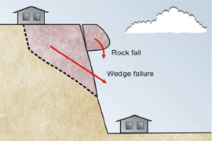

**Fig. (3): Wedge failures**

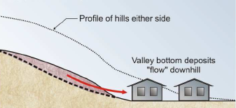

**Fig. (4): Debris flows and mud slides**

**2. LANDSLIDES IN ROCK**

Rocks have been formed by many different geological processes and may have been subjected to intense pressure, large scale distortion, extreme temperature and chemical change. As a result there are many different rock types and their condition varies enormously. Rock strength varies and is often significantly reduced by the presence of discontinuities. You may think that rock lasts forever, but in reality it weathers under the combined effects of water, wind, chemical change, temperature variation, plant growth and animal activity and erodes with time. Rock is often the parent material that ends up forming soil slopes. Inevitably different rocks have different physical and chemical characteristics and they weather and erode to form different types of soil. Weathering can lead to landslides on rock slopes. The type of landslide depends on the nature of rock, the way it has weathered and the presence or absence of discontinuities. It is hard to generalize, though normally a specific combination of discontinuities and material types will be the determining factor and these are often underground and out of sight. Typical examples are provided in the Figures 5 through 8. A geotechnical practitioner can assess the landslide risk and propose appropriate maintenance measures. This often entails making geological observations over an area significantly larger than the site and a review of available background information, including records of known landslides and aerial photographs. Depending on the amount of information available, geotechnical investigation may or may not be needed. Every site is different and every site has to be assessed individually. It is impossible to predict exactly when a landslide will occur on a rock slope, but failure is normally sudden and the consequences can be catastrophic.

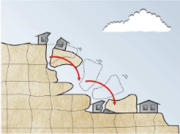

**Fig. (5): Failure of an undercut block**

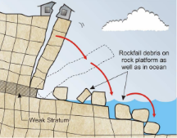

**Fig. (6): Toppling failure**

If the landslide risk is assessed as being anything other than low, or very low, it may be possible to carry out work aimed at reducing the level of risk (GeoGuide LR, 2007).

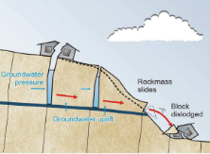

**Fig. (7): Block slide on weak layer**

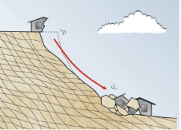

**Fig. (8): Wedge failure along discontinuities**

**3. LANDSLIDE PREVENTION AND MITIGATION**

There are several ways to try to prevent landslides. Most prevention methods employ various engineering controls to minimize the hazard and stabilize a slope.

If a landslide occurs, mitigation means reducing the effects or the intensity of the landslide. After a landslide occurs, the first task is to remove the landslide material and stabilize the slope.

Most methods of mitigation overlap with preventive measures are:

1. Vegetation. Planting vegetation is particularly effective in stabilizing slopes that consist of sediment. The roots bind the loose sediment and may penetrate to the underlying rock to anchor the sediment. Vegetation is deep roots is more effective. Vegetation also helps stabilize slopes by absorbing water from the soil

2. Retaining Walls. The purpose behind a retaining wall is to strengthen an oversteepened slope. Retaining walls are especially common along roadsides where a flat or level surface has been cut into a slope for the roadway.

3. Controlling Water. We saw that water plays an important role in mass wasting. Various engineering controls are employed to “dewater” a slope to increase its stability in wet conditions.

4. Rock bolts are installed by drilling a hole through the slope then inserting and anchoring the bolt. Rock bolts are frequently installed with flexible metal mesh to help stabilize the slope and prevent material from falling as shown in Figure 9.

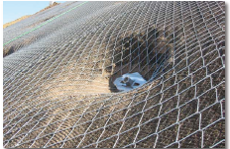

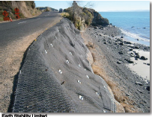

**Fig. (9): Metal mesh to stabilize the slope and prevent rock falling**

**4. STUDY LOCATION**

This study was performed on two areas included Al Bakour and Al Shaliony, that lie in the northeast region of Libya (Figure 10)., between latitudes 32o 52 23" and 20o 62 70 N and longitudes 32o 49 63 and 20o 96' 39 E (Figure 1).

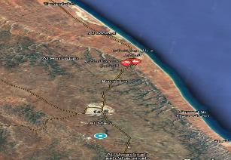

**Fig. (10):Location map of the study areas**

**5. STATEMENT OF PROBLEM**

The long-term stability of highway road cuts is of crucial importance to public safety. Road-cut failures are known to cause not only traffic disruptions, but they can also be responsible for accidents and fatalities. In Libya, most of the rock cuts in highways and mountainous roads, in the northeastern region, are exposed to the hazard of slope failure due to several factors, particularly the investigated areas that exposed to heavy rainfall conditions.

Thus, the determination of the stability condition of highway rock slopes made up of variable rock mass structures and subjected to the various conditions is of crucial importance. This will be the main focus of this research.

**6. OBJECTIVES OF STUDY**

The initial objective of this study was to catalogue the surficial character, current conditions and rockfall potential for rock exposures along the roadways of the area under investigation.

The term rockfall is used in this paper as a generic term for rockfalls and rock slides of all kinds, whether rock is free falling, toppling, bouncing, rolling or sliding. Field investigations were carried out in the rock cut area to determine the most influential geological and geotechnical characteristics of the rock material in the area and to assess the most significant factors affecting the slope stability.

The detailed objectives were to:

1. Review and examine the validity of existing methods to assess rock slope stability under various factors.
2. Describe the most relevant factors contributing to the slope instability hazards in the site.
3. Collect discontinuity data to obtain sufficient information regarding the geological structures and discontinuity patterns and the effect of their orientation on modes of failure (planer and wedge failure analysis),

**METHODOLOGY**

***--------------------------------------------------------***

This study has been carried out through the fieldinvestigation to characterize rock cuts along roadways. It was initially estimated that this study would collect data for the two rock cuts. However, during the course of the study additional exposures were identified on which data were collected. The final number of exposures examined. Additionally, several exposures that had long been recognized for their rockfall and slope failure potential were examined, characterized, utilizing the photography methods to illustrate the morphological features.

**GENERAL SURVEY ELEMENTS**

As mentioned previously the first type of data collected for this study was general information. Besides location data, this includes information about the physical appearance of the roadside, such as slope and climate and vegetation characteristics.

**1. Slope Information**

Each roadway exposure was initially characterized by its size and shape. Height was estimated from the bottom of the rock cut to the top of the slope (Figure 11A). At some outcrops the top of the slope was marked at the base of the first or second bench if the portion of the cut above this point did not appear to be contributing material to the slope below. Slope exposure was measured with a compass clinometer as the average angle in degrees of the slope face. Beds of rock protruding from the slope were noted as potential launching factors, since they present the possibility of loose material being rolling down the slope and being discharged on to the roadway (Figure 11B).

**2. Benches and Catchment Character**

The presence of a catchment area adjacent to the roadway provides space where fallen debris can come to a rest rather than enter the roadway. Benches represent catchment areas that are elevated above the roadway. When empty, these features can be horizontal or inclined away from the roadway: however, they can become inclined toward the roadway when filled (Figures 12A-C).

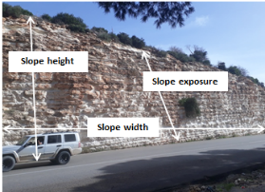

**(A) Slope dimensions (Al Bakour area)**

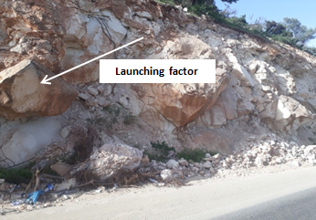

**(B) Launching factors(Al Shaliony area)**

**Fig. (11): Embankment characterization**

The presence or absence of benches is generally dictated by the height of the exposure. Those greater than forty feet in height typically possessed at least one level of elevated bench (Figure 12D). Although benches represent elevated catchment areas, when they become filled with debris they can themselves become a launching factor, propelling rolling debris on to the roadway, and beyond roadside catchment (Figure 12E). Thus, filled benches switch from a safety factor to a hazard. When benches become filled, they also tend to spawn vegetation growth (Figure 12F).

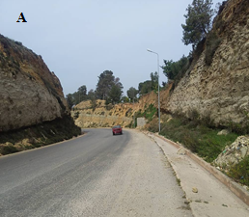 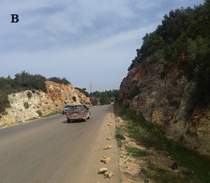

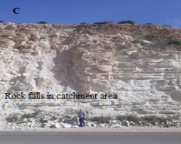

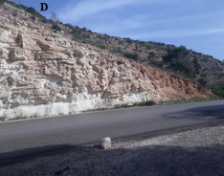

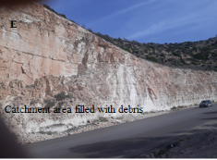 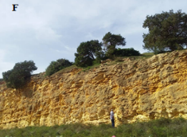

**Fig. (12): Benches and catchments styles and character. A, Catchment shoulder sloping away from roadway (Al Bakour area). B, Flat catchment shoulder (Al Bakour area). C, Elevated catchment bench clear of debris (Al Bakour area). D, Shoulder inclined towards roadway. E, Elevated bench nearly filled with debris. F, Elevated bench with woody vegetation (Al Shaliony area)**

**3. Climate**

The climate of a region dictates the amount and type of weathering that affects the rock outcrops in the area. Four categories were created to encompass climate variations, but only two effectively summarize these factors in the study areas. The first was moderate precipitation. This category was used for most outcrops. The second category used was high precipitation. This entry was used for outcrops along highways within the two areas under consideration.

**4. Water on/from Exposure**

Water seeping from or running on rock slopes constitutes a significant secondary contributing factor to roadside slope failure potential for several reasons (Figure 13). Most importantly, water can serve as a lubricant that reduces friction between rock layers and along fractures and parting surfaces. This reduced friction, especially where failure planes are steeply inclined, can contribute to the triggering of slope failure events. Where subvertical, fractures can increase the conductivity of the water downward into subsurface stratification planes and reduce friction along those surfaces.

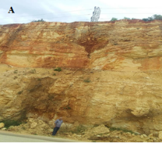 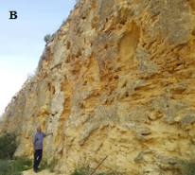

**Fig. (13): Degrees of variation in the amount and distribution of water on roadside slopes. A, Water seeps along stratification (Al Shaliony area). B, Water seeping along joints and fractures (Al Shaliony area)**

**5. Slope Vegetation**

The prominence and type of vegetation can play a significant role in roadway slope failure. Rooting by grassy and woody vegetation is an important component of the physical and chemical weathering of outcrops in temperate biomes. Consequently, biotic element are not only attracted to these locations. Their rooting can further fragment rocks and their rootlets can propagate along fractures to loosen blocks and boulders. As a general observation, vegetation of all types tends to be better developed both where water is present on the outcrop. North-facing slopes maintain moisture that allows increased vegetation development (Figure 14A). The presence of grassy vegetation on south-facing slopes tended to be present where water was preserved in fractures and partings of the bedrock units (Figure 14B). Saplings and rooted trees were generally found to verify the findings in that they tended to be better established on the north-facing exposures at road cuts (Figures 14C, D).

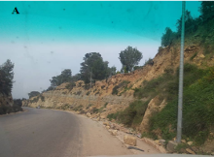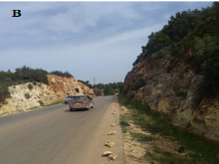

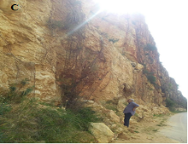

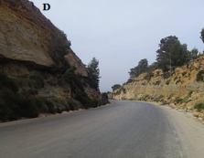

**Fig. (14): Types of vegetation on roadside slopes. A, Grassy and herbaceous flora (Al Shaliony area). B, Grasses in clumps or coatings (Al Shaliony area). C, Rooted saplings. D, Embedded and rooted tree trunks**

**6. Type of Hazard**

Four generalized categories of slope failure were utilized for this study. The first of these hazards is rockfalls, which encompasses rock topples. This type of failure requires a precipitously steep slope at the outcrop, often in excess of 80 degrees. Moreover, adverse failure planes frequently create greater potential for this type of failure (Figure 15A). The second category of slope failure is termed rock roll (Figure 15B).

This most common type of failure varies in prominence based upon the inclination of the slope. Commonly, slope angles between 50 and 70 degrees yield rock rolls. Lithologies that typically are associated with rock rolls are chalk/limestone and shale where differential weathering is prominently identified. Rock slides are a failure type that tends to occur where stratification is inclined towards the highway (Russell et al., 2008) (Figure 15C).

This category includes detachments that are parallel to subparallel to bedding surfaces. Slide type failures tend to be intricately associated with the presence of intersecting groups of joints that can be oriented sub-perpendicular to the direction of the slide. The jointing, whether discontinuous or continuous, provides areas that allow detachment of rock slabs near the head of the slide.

These types of slope failures are much more common in the highly structures investigated areas. The last category of hazard considered was slump or rotational slides (Figure 15D). This type of hazard tended to be observed in outcrops that were highly weathered and vegetated, or where thick soil intervals had developed on steep slopes.

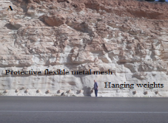

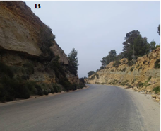

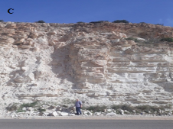 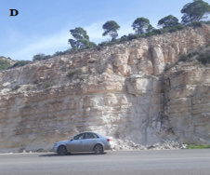

**Fig. (15): Type of slope failures and resulting hazards identified during this study. A, Rockfall. B, Rock roll. C, Rock slide. D, Slump (rotation) scar (Al Bakour area)**

**GEOLOGY SURVEY ELEMENTS**

The second type of data collected for this study is geologic factors. These data include information on lithology, stratification, differential erosion, and the character of failure planes in the rock. Vanderwater et al. (2005) attempted to classify and correlate dependence of slope failure mode on geologic variables. Their study indicates that lithologic variations and the number of discontinuities (i.e. failure planes) are significant predictors of rockfall type.

**1. Failure Plane Character**

It was an *a priori* assumption of this study that the type, orientation, and character of the dominant fracture system in the bedrock, whether joints, faults, or stratification, represented a prevailing factor in roadside slope failures. These fracture systems were noted during observations made during the course of this study and are recognized as potential failure planes. This assumption is based on previous studies of roadside rock slope failures (Russell et al., 2008).

Joints are planar to subplanar brittle fractures of the bedrock along which no perceptible movement has taken place. They tend to form by shear or extensional stresses. Joints generally occur as semi-rectilinear patterns that are recognized in investigate strata. These fractures are generally discontinuous where they are displayed within interbedded lithologies, but are more continuous where they pass through massive interbedded lithologies (Figure 16). The number, spacing, and orientations of joint sets vary with respect to the bedrock composition. Road excavation through massive rock types can lead to the formation of extensional joints that form parallel to the roadway. In such cases extensional joints form from the release of confining pressure. These extensional joints are especially common within limestone units of the formations under consideration.

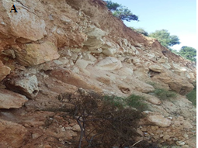

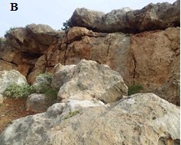

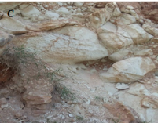

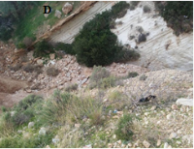

**Fig. (16): Failure plane character. A, Discontinuous and favorable orientation (Al Bakour area). B, Discontinuous and random orientation (Al Shaliony area). C, Discontinuous and adverse orientation (Al Bakour area). D, Continuous and adverse orientation (Al Shaliony area).**

The orientation of joints or other fracture systems with respect to the roadway is important to note because such failure planes dictate a propensity and direction of slope failure. For the current study, joints and fractures that dipped away from the roadway were considered adverse while those dipping towards the highway were recognized as favorable (Figure 16). Although this may seem contrary to general reasoning, it was theorized that the adverse orientations were more likely to produce rockfalls and favorable more likely to yield rock slides and rock rolls. Vanderwater et al. (2005) noted that using the terms favorable and adverse for rockfall hazard was “ambiguous.” This is because the term favorable when used for fracture plane characterization implies favorable as stable, and did not necessarily represent favorability for failure.

**2. Rock Friction**

While the orientation of the fracture planes is important in regards to the type of failure, the intrinsic character of the fracture provides insight into its origin and potential for movement. This character is herein termed *rock friction*. Rock friction, where observable, was cataloged only for the primary fracture system (Figure 17). At some exposures this was the dominant joint set, while at others it is represented by partings along stratification or faults. Identifying this character is considered important because it provides insight as to the potential for further movement along the observed discontinuity. Rough surfaces have a rough and irregular texture to the touch (Figure 17A). Undulating surfaces suggest a level of shearing and movement along the surface (Figure 17B). These surfaces tend to be rounded rather than smooth and planar. Planar surfaces typically display smooth surfaces that may be parallel to one another (Figure 17C). Lastly, slickenside surfaces are tectonically smoothed fractures and suggest that movement parallel to the fracture surface has taken place (Figure 17D).

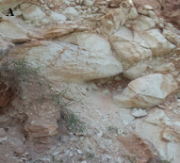 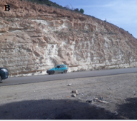

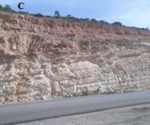

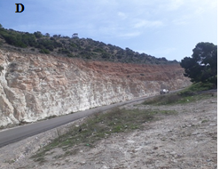

**Fig. (17): Rock friction. A, Rough and irregular. B, Undulating. C, Planar. D, Slickensides (Al Shaliony area)**

**3. Differential Erosion**

There are considerable differences in the rates of weathering and erosion, when one considers lithology, slope angle, outcrop compass orientation, and physiographic province. These variations in erosional susceptibility can produce a range of rock overhang characteristics that can result in increased likelihood of rock failure (Figure 18). The rock types least affected by such erosion are massive lithologies such as limestone, siltstone, and to a lesser degree shale (Figure 18A). Because of their homogeneity these lithologies typically have fewer bedding discontinuities along which weathering and erosion can occur. These lithologies tend to form a subvertical wall with little overhang. In contrast, interbedded lithologies provide varying levels of both weathering and erosion. This variation is known as differential erosion (differential weathering of Vanderwater et al., 2005). The pervasiveness of interbedding is also a key component in the potential for the number and prominence of differential erosion features (Figures 18B).

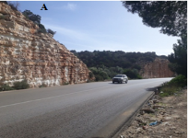 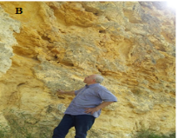

**Fig. (18): Differential erosion. A, Major differential erosion within massive chalk (Al Bakour area). B, Many differential erosion surfaces within limestone and shale (Al Shaliony area).**

**4. Weathering Character**

Weathering character is closely related to differential erosion (Figure 19A). While Vanderwater et al. (2005) considered these to be the same factor, they will be treated separately herein. Newly created exposures generally present no substantial weathering characteristics. However, with age, rock exposures develop features as a result of weathering. No study outcrop in investigated rocks was considered freshly exposed. Massive rock exposures that are susceptible to chemical and physical weathering, have been exposed for a considerable time, or are oriented so that weathering is more effective, tend to display irregular surfaces (Figure 19B). Many more outcrops were categorized as being weathered in relief. These are especially common within limestone strata where solution has removed shaly or more soluble layers along stratification (Figure 19C). The final category, weathered with overhanging ledges, is considered typical of thick interbedded lithologies, where more massive intervals of rock are interbedded or underlain by more easily removed lithologies (Figure 19D). In this case, weathering produces overhanging ledges created by major differential weathering and erosion. Overhanging ledges appear to be more prevalent where higher levels of freeze-thaw cycles and precipitation are present. Thus, rock exposures of the studied areas show greater levels of differential weathering.

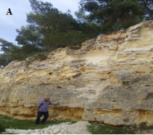 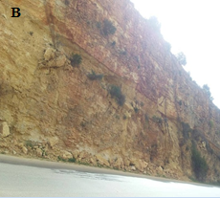

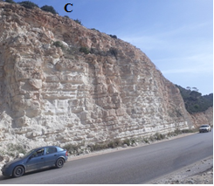

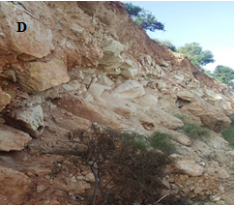

**Fig. (19): Weathering of outcrop. A, B, Weathered on surface (Al Shaliony area). C, Weathered in relief. D, Weathered with overhanging ledges (Al Bakour area)**

**5. Stratification**

Because all of the rocks in the study areas are sedimentary in origin, all bear some level of layering, otherwise known as stratification, or more commonly, bedding (Figure 20). The type, character and orientation of stratification are critical to the understanding of the type of potential slope failure. Massive strata, because of their internal structure, tend to have fewer numbers of failure planes and differential erosion surfaces (Figure 20A). This character, especially common when the rocks are nearly horizontal, tends to present steep roadside slopes and often an elevated launching potential. Strata whose dips are oriented parallel to the roadway present greater thickness of strata available for weathering and exposure, although there is a reduced potential for strata decoupling and sliding into the roadway (Figure 20C-D). Strata dipping into the roadway tend to present greater potential for slides, glides, or detached rock masses where rock can be displaced into the highway right-of-way (Figure 20E). Likewise, this orientation of stratification provides abundant potential for rock roll events where weathered and decoupled blocks can roll down the inclined slope and into the roadway. By contrast, strata dipping away from the roadway can present steep slopes, but a reduced potential for either slides, falls, and rolls (Figure 20F).

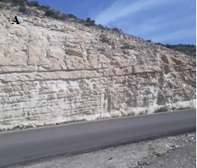

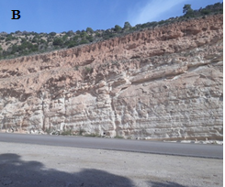

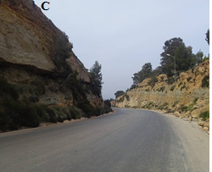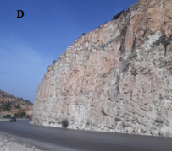

**Fig. (20): Stratification. A, Stratification horizontal (Al Bakour area). B, Stratification inclined parallel to road at <30 degrees (Al Bakour area). C, Stratification inclined into roadway (Al Bakour area). D, Stratification inclined away from roadway at ˃30 degrees (Al Shaiony area).**

**6. Lithology**

The composition, or lithology, of the rocks through which a road cut passes is a fundamental geologic aspect that affects potential for slope failures (Figure 21). Massive limestone tend to create steep slopes adjacent to the roadway, and based upon the type and prominence of failure plane within these rock types, may create the potential for rockfalls and rock rolls (Figure 21A). Lithologies that are pervasively interbedded present the greatest potential for differential weathering (Figure 21B, C). Within these lithologies, failure planes may create an increased potential for rockfall and rock roll. If such interbedded lithologies are oriented with dips into the roadway, especially when water is concentrated along bedding planes, they present the greatest potential for massive rock slides. Subhorizontal intervals of massive shale rarely are capable of creating steep slopes. These units tend to weather to slopes of small chips and thick soil. These slopes are readily vegetated, and where abundant water is available, can produce slumps and rotations into the roadway. Lastly, irregular conglomerate blocks in existing or preexisting landslides can form incoherent masses of loose blocks (Figure 21D). These blocks can roll or slide into the roadway under the influence of frost action or gravity.

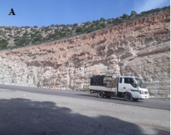

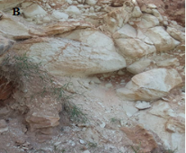

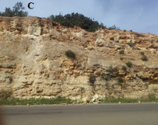

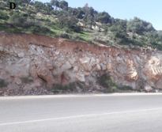

**Fig. (21): Lithology. A, Massive chalk. B, limestone/shale with shaly interbeds. C, limestone with shale interbeds. D, Block in matrix.**

**RESULTS AND DISCUSSION**

***--------------------------------------------------------***

The results from field identification of the landslide in the study area showed a several landslide points. The landslide was located on the edge side near the high way road. More landslide points are found in the location of Al Bakour area compared to the location of Al Shaliony area, due to the different the different factors that discussed previously.

Landslides are also triggered by the slope factor. Steeper slopes have less friction; hence, increasing the likelihood of landslide (Çellek 2022).

Landslides were caused by high-intensity rainfall, referring to the studies on landslides globally (Polemio and Petrucci, 2000; Ferardi, Wilopo, and Fathani 2018), the statement is an undeniable scientific fact.

One way to protect the rock cliff from slope failure is to construct cliff protection like an em­bankment (Masannat, 2014; Kimura, Nagata and Kan, 2020); however, this will demand a costly investment if the cliff were high and extensive (Chakrabarti and Cheenikal, 2013; Zhang and Chen, 2019). Embankment construction in some landslide points has been constructed and elevated; therefore, it requires huge spending.

Franklin et al., (2013) stated that vegetation is a group of several trees growing together in a given space that forms one integrity, of which each species were in co-dependency to each oth­er, known as a plant community. According to Forbes et al., (2013); Lu (2014); Widjaja, (2018); (Phillips et al., 2021) the most appropriate veg­etation for slope and cliff protection is the local one. Local vegetation has been adapted and is suitable for its endemic; thus, capable to function in its growing space. In this case, if they grow in the cliff area, they already functioning to protect the space and environment (Freschet et al., 2018). The observation of the local vegetation in the investigated locations that could reduce the landslide im­pacts has a land cover feature of grass in the below strata; shrubs in the middle strata; and trees in the upper strata. These three strata worked together to hold the soils firmly and provide optimum protec­tion to the rock failure of cliffs of areas under consideration.

**CONCLUSIONS**

From the findings of the previous study, the following conclusions can be drawn:

1. The identification results show that there a several rock collapses and landslide points on the slopes and cliffs of the studied formations in both areas due to the slope instability factors.
2. Rock failure and landslide occur due to the land use change from forest to a plantation, road cutting and slope, particularly in a cliff area that was carved for road development purposes.
3. Other factors include the geology of the areas that was part of slopes instability.
4. The rainfall fac­tor is the main cause of the landslide in the study areas because of the activation of weathering factors and weakness of rock cohesion.

Mitigation for the landslide in the formations cliffs in the areas can be done under the eco-engineering ap­proach through revegetation using local/native species.

**REFERENCES**

***--------------------------------------------------------***

**­­­­­­­­­­­­­­­­­­­­­­­­**

Australian GeoGuide, LR (Landslides) (2007) Coastline Hazard Management Study for the Wyong Shire Council Australian Geomechanics Vol. 42 No 1.

Burns, W.J., and Madin, I.P., (2009) Protocol for inventory mapping of landslide deposits form light detection and ranging (LIDAR) imagery. Oregon Department of Geology and Mineral Industries Special Paper 42, 30 p.

Çellek, S. (2022) Effect of the Slope Angle and Its Classification on Landslides. Natural Hazards and Earth System Sciences, 43(1), 85–95.

Chakrabarti S., Cheenikal L., Singh G. (2013) Em­bankment Design and Construction for a Major Rail Upgrade Project in Embankment Design And Con­struction For A Major. Australian Geomechanics Journal, June, 1–8.

Ferardi F.D., Wilopo W., Fathani T.F. (2018) Rainfall Thresholds for Landslide Prediction in Loano Sub­district, Purworejo District Central Java Province. Journal of Applied Geology, 3(1), 23–31.

Forbes K., Broadhead J. (2013) Forests and Land­slides : The Role of Trees and Forests in the Preven­tion of Landslides and Rehabilitation of Landslide- Affected Areas in Asia. Bangkok.

Franklin J., Robert P., Roberts D.W., Austin M. 2013. Vegetation Ecology, 2nd. Ed. In Vegetation Ecology, Jhon Wiley & Sons, Ltd, 71–106.

Freschet G., Violle C., Roumet C, Garnier E. (2018) Interactions between Soil and Vegetation : Structure of Plant Communities and Soil Functioning. In Soils as a Key Component of the Critical Zone 6: Ecology, ISTE Ltd and Jhon Wilye & Sons, Inc., 83–104.

Kimura K., Nagata T., Kan S. (2020) Landslide Di­saster and Its Prevention Works in Shikoku Region of Japan Landslide Disaster and Its Prevention Works in Shikoku Region of Japan. IOP Confer­ence Series: Earth and Environmental Science, 589(012009), 1–12.

Kumar N, Verma AK, Sardana S, Sarkar K, Singh TN (2017) Comparative analysis of limit equilibrium and numerical methods for prediction of a landslide. Bull Eng Geol Environ77(2):595–608.

Lu P.L. (2014) Using Multiple Vegetation Layers to Reduce the Risk of Rainfall-Induced Landslides and Facilitate Post-Landslide Slope Rehabilitation. Ac­cess International Journal of Agricultural Sciences, 2(2), 13–17.

Masannat Y.M. 2014. Landslide Hazards : Geo­technical Aspects and Management Policies. Jordan Journal of Civil Engineering, 8(1), 1–22.

Park HJ, Lee JH, Kim KM, Um JG (2016) Assessment of rock slope stability using GIS-based probabilistic kinematic analysis. Eng Geol 203:56–69

Phillips C., Hales T., Smith H., Basher L. 2021. Shallow Landslides and Vegetation at the Catch­ment Scale : A Perspective. Ecological Engineering, 173, 106436.

Polemio M., Petrucci O. 2000. Rainfall as a Land­slide Triggering Factor : An Overview of Recent International Research. The 8th International Sym­posium on Landslides in Cardiff, UK 3(January).

Pradhan SP, Vishal V, Singh TN (2018) Finite element modelling of landslide prone slopes around Rudraprayag and Agastyamuni in Uttarakhand Himalayan terrain. Nat Hazards 94(1):181–200

Russell, C.P., Santi, P., Higgins, J.D., 2008. Modification and statistical analysis of the Colorado rockfall hazard rating system. Colorado Department of Transportation Report CDOT-2008-7, 124 p.

Sarkar S, Kanungo DP, Kumar S (2012) Rock mass classification and slope stability assessment of road cut slopes in Garhwal Himalaya, India. Geotech Geol Eng 30(4):827–840.

Sardana S, Verma, AK, Singh A, Laldinpuia (2019) Comparative analysis of rockmass characterization techniques for the stability prediction of road cut slopes along NH-44A, Mizoram, India. Bull Eng Geol Environ.https ://doi.org/10.1007/s1006 4-019-01493 -3

Singh AK, Kundu J, Sarkar K (2018) Stability analysis of a recurring soil slope failure along NH-5, Himachal Himalaya, India. Nat Hazards 90(2):863–885.

Schulz, W.H., (2004) Landslides mapped using LIDAR imagery, Seattle, Washington. U.S. Geological Survey Open File Report 2004-1396, 11 p.

Schulz, W.H., (2007) Landslide susceptibility revealed by LIDAR imagery and historical records, Seattle, Washington. Engineering Geology, 89:76-87.

Vanderwater, C.J., Dunne, W.M,, Mauldon, M., Drumm, E.C., and Bateman, V., (2005) Classifying and Assessing the Geologic Contribution to Rockfall Hazard. Environmental and Engineering Geoscience, 11:141–154.

Verma AK, Singh TN (2010) Modeling of a jointed rock mass under triaxial conditions. Arab J Geosci3(1):91–103

Verma AK, Singh TN, Chauhan NK, Sarkar K (2016) A hybrid FEM–ANN approach for slope instability prediction. J Inst Eng (India) Ser A 97(3):171–180.

Verma AK, Sardana S, Singh TN, Kumar N (2018) Rockfall analysis and optimized design of rockfall barrier along a strategic road near Solang Valley, Himachal Pradesh, India. Indian Geotech J 48(4):686–699.

Verma AK, Sardana S, Sharma P, Dinpuia L, Singh TN (2019) Investigation of rockfall-prone road cut slope near Lengpui Airport, Mizoram, India. J Rock Mech Geotech Eng 11(1):146–158.

Vishal V, Siddique T, Purohit R, Phophliya MK, Pradhan SP (2017) Hazard assessment in rockfallprone Himalayan slopes along National Highway-58, India: rating and simulation. Nat Hazards85(1):487–503.

Widjaja H. (2018) Vegetative Engineering as Landslide Reduction and Handling Alternative. In IOP Conf. Se­ries: Earth and Environmental Science, 203, 1–4.

Zhang Z., Chen Z. (2019) Constraint Embankment Construction to Prevent the Collapse Of. Advances in Civil Engineering, 2019, 1–18.