give your article a catchy title, easier

for journal editors to evaluate

(font, Calibri & size, 24)

Author names, Sont and Size

|  |  |  |
| --- | --- | --- |
| A R T I C L E I N F O  ***Vol. 3 No. 1 June, 2021***  Pages (1- 4)  *Article history:*  Revised form 07 December 2020  Accepted 31 January 2020  *Authors affiliation*  *itaklic*  *Font & size*  [email@mail.com](mailto:email@mail.com)  ***Keywords:***  **Font & size**  © 2021 LJEEST. All rights reserved. Peer review under responsibility of LJEEST |  | **A B S T R A C T**  Time New Roman Font size 10 bold  **An abstract is a brief paragraph that gives an overview of the article at the beginning of an academic paper. When applying to give a talk, abstracts are frequently included on posters or submitted to conferences. A free abstract is available for virtually every article on indexing sites.**  **An overview of the paper is the purpose of the abstract. As a result, it has the same structure as the main text and functions as a "mini" version of the paper.**  **• The study's topic and purpose are introduced at the outset.**  **• It then provides a brief explanation of the study's methods.**  **• The study's conclusion(s) and the significance of the findings are discussed at the conclusion.**  **Even though the abstract is often read first in a paper, it is usually a good idea to write it last. The paper can be written first to help you organize your thoughts and gain a better understanding of your study's key components.**  **While the content of the paper should be reflected very closely in the abstract, you should avoid copying and pasting sentences from the main text because doing so can result in awkward wording and too much detail.**  **Last but not least, before sending in your abstract, you might want to check to see if it includes the keywords that best describe your research. It would be ideal if the title, abstract, and text for the main body all naturally contained the same small group of keywords. Therefore, a quick check for these can assist you in determining how precisely the abstract's content corresponds to the main paper's content.**  **العنوان العربي**  المؤلفين    Traditional Arabic Font Size 10 |

INTRODUCTION

***--------------------------------------------------------***

Time New Roman Font size 10

APA in-text citation style uses the author's last name and the year of publication, for example: (Field, 2005).

The first section of an academic article is the introduction, which follows the abstract. The purpose of an introduction is to provide an answer to the question "why?" What motivated the study, as well as what makes it interesting, significant, or both? Since the introduction is the first part of the paper, it also tells the reader why they should read the rest and helps them understand the results' significance and implications.

The four main components of the introduction are intended to clearly establish the study's context:

Background information in general Particular background information An explanation of the knowledge gap that the study was meant to fill A statement of the study's goal and, if desired, a brief summary of the study. The information should be presented in a "funnel" format, moving from the most general information at the beginning of the section to more specific information as the text goes on. Let's examine each of these components in turn in greater detail.

The next section of the introduction ought to go into greater detail about the primary subject of the study after the general context of the study has been established. In order to give readers a clear picture of what is already known about the subject, this section of the introduction includes a literature review in which other studies that have addressed similar themes are discussed in detail. The purpose of this section is to provide a comprehensive overview of the current state of the field, which will assist in demonstrating how your research builds upon previous work. Readers gain a better understanding of your design process and the logical steps that led you to formulate the primary question addressed by your study when you describe the current state of the field.

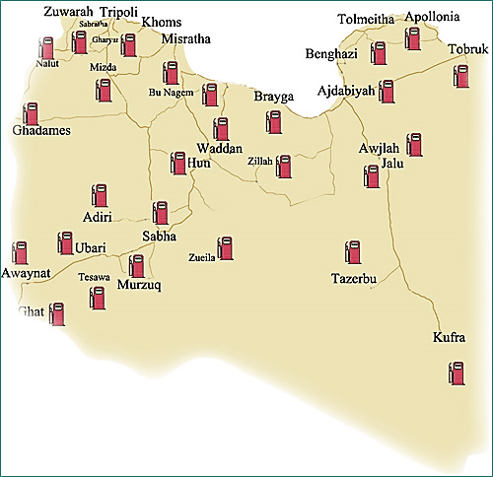

**Fig. (1): The map of Libya**

As previously mentioned, a specific void in our comprehension of a particular issue or phenomenon in the field should be elucidated by the description of closely related previous studies. Simply describing the work that has recently been done to investigate related questions can sometimes accomplish this; For instance, if a disease's risk factors have been studied in African, European, and Asian populations but not in Asian populations, explaining what is known about the disease in those populations will help readers comprehend why the same question should be investigated in an understudied population. In other instances, it may be appropriate to (respectfully) highlight the ways in which your study enhances this previous work by pointing out the shortcomings or drawbacks of comparable studies. You could, for instance, emphasize the significance of incorporating additional properties to justify the requirement for the brand-new computational model described in your study in the event that previous studies have developed models that take into account some but not all of the properties of a particular reaction.

A clear statement of the primary objective of the study is the final component of the introduction. This may be the primary overarching question the study sought to answer in some instances; This might be a formal hypothesis in other situations; and this may be a goal in yet another instance. In order to ensure that readers have a clear understanding of the specific purpose of the study before proceeding to read about it in greater detail in the sections that follow, it is essential to clearly state the study aim, ideally in the final paragraph of the introduction. To convey a cohesive and consistent message regarding the purpose of the study, keep in mind that this statement of the study aim should closely mirror the statement of the study aim in the abstract.

A summary paragraph that provides a very succinct overview of the primary findings and overall conclusion may be appropriate at the conclusion of the introduction in some instances. In the context of the background information provided in the remainder of the introduction, this brief paragraph can help readers recall the study's key points and provide a framework for comprehending the remainder of the text.

In summary, a well-written introduction provides readers with all the information they need to understand why you conducted your study, how it differs from other studies of a similar nature, and why the findings are interesting and significant. This sets the tone for your paper.

Materials and Methods

Time New Roman Font size 10

The methods section is easy to write, but it requires a lot of technical details, so it can take a long time to write. You will describe how you carried out your study in this section. It is of the utmost importance to readers and reviewers that this section is clear and complete. Journal editors and peer reviewers alike will give this section a lot of weight during the peer review process. In order for readers to have faith in the results of your research, they will also require assurance regarding how you carried it out. To put it another way, other researchers will use the information you provide in your methods section to determine whether your findings and conclusions are valid.

The research design you selected should be described. Describe why you chose this design and how it will make it easier to achieve your study's goals by connecting it to the project's goals. In a Psych article, for instance, Crawford and Loprinzi (2019) describe their design.

Give a description of the people who took part in your study. Any demographics that are relevant to your research should be included. For instance, if age is a factor in your study, provide data on how participants are distributed among different age groups. When it comes to displaying demographic data, tables can be very helpful. Did you use a convenience sample, a selected sample, or random sampling? Describe how the sampling method you used is compatible with your research questions and why it is appropriate for the study. Holm et al., for instance In their study, "Big-fish-little-pond effect on achievement emotions in relation to mathematics performance and gender," 2020) display important demographic information about participants in a table.

Give an explanation of how you gathered the data. Include any measures taken. All of your research instruments should have information about their validity and reliability. Give a description of any materials used in the study. Last but not least, list the steps in the order they were taken in the procedure. Always include specifics about any measures taken to prevent bias and threats to the study's validity.

Describe your data analysis process. Include a description of any power analysis you carried out and the statistical tests you used. Crawford and Loprinzi (2019) describe their statistical analyses in the aforementioned paper.

JASP (v. 0.9.1; IBM SPSS, Armonk, NY, USA) or SPSS (v. 23, IBM SPSS) were used for all analyses. Netherlands). Calculations were made for both Bayesian and frequentist analyses. For the frequentist analyses, the memory outcomes of the control, moderate, and vigorous conditions were compared using the repeated measures analysis of variance (RM-ANOVA). Bayesian RM-ANOVA analyses were used in addition to these frequentist analyses because Bayesian analyses do not assume large sample sizes, and it is typically possible to analyze smaller sample sizes without sacrificing power or precision [66,67]. Bayes Factors (BF) are reported for the Bayesian RM-ANOVA, and a BF greater than 3.0 indicates substantial support for the alternative hypothesis [68]. An a priori alpha level of 0.05 was used to determine statistical significance for the frequentist analyses. p.295)

1. When writing the methods section, it's a good idea to outline it and add information as you go along with your research project. Along these lines, you will have serious areas of strength for a when you come to composing your scholarly paper. You can edit and update portions of this section from the proposal if your paper is the result of research for which you submitted a proposal.

2. This section's layout is very important. You want to make it simple to follow for readers and reviewers alike. Read and comprehend all of the journal's formatting guidelines before submitting your work. Divide the various sections using the appropriate subheadings. Examining the headings and subheadings used in other articles from your target journal can be helpful.

3. Describe the methods in sufficient detail to allow the reader to follow your study's progress. While composing a scholastic paper, you should track down a harmony between giving adequate detail and being brief. Ask coworkers to read this section of your draft paper and give you feedback on whether they think it contains enough detail and is rigorous in its current form.

4. Use appropriate visuals to break up the text and help the reader understand what you're saying. If your study involved an intervention, you might include a graphic that describes the intervention or shows how it was carried out. Additionally, a table can be used to describe the study's activities, their dates, and who the participants were. Academics frequently use tables to show how the collected data, analyses of the data, and research questions are aligned.

5. Get advice from people who are familiar with your approach. Colleagues can assist in ensuring that your explanation of the methods is clear and accurate. Technical expertise is invaluable. They can also give you feedback on any important details in your paper that they think are missing. It's also a great way to get useful feedback that can help you improve your paper to reach out to colleagues who have reviewed papers for scientific journals.

6. Continue reading at least once more. You can't read too many articles about research. You can get a lot of ideas and motivation from these. Your writing process will go much more smoothly if you observe how academics who have published successfully approach the methods section of their papers.

Results and discussion

***--------------------------------------------------------***

Time New Roman Font size 10

In your academic paper's discussion section, you explain what your results mean and link them to previous research studies. In the results section, you present what you found during your analyses. In other words, you should describe what you did in the results section and what this means for the field in the discussion section.

The findings of your research should be presented in the results section without any interpretations or implications. You use text, tables, graphs, and other figures to support your presentation of the findings in this section. Take, for instance, the manner in which Tolksdorf, Crawshaw, and Rohlfing (2021) report the findings of their study in the following excerpt. The authors use a table to illustrate their findings further in the results section.

As may be obvious, the outcomes area is exceptionally immediate and reports the result from the measurable investigations led. Because it can be very technical, this section can be broken up with tables and figures. Additionally, readers are made more aware of the findings thanks to the use of visuals in this manner.

**Table (1):**

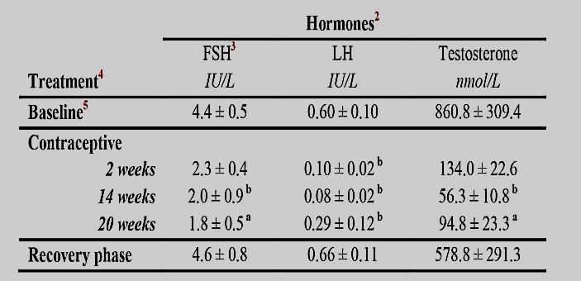

An explanation of the results will be provided in the discussion section that follows the results section. You should make explicit connections back to your research question(s) and include an explanation of how the results might be generalized in this section. You should also connect your findings to those of previous research studies. You make an argument here to back up your main conclusions. The discussion section, in contrast to the results section, is where you interpret your results and explain what they mean, draw implications from your results and explain why they are important, discuss any limitations of your results, and offer suggestions based on these results. The distinction between the results and discussions sections is further illustrated by the following passages from Tolksdorf, Crawshaw, & Rohlfing (2021).

Despite the repeated interaction and growing familiarity with the situation, we were unable to observe a significant decrease in children's social referencing in either group, contrary to our initial assumption. Although each group appeared to have a slight tendency to decrease from the second to the third learning situation, this trend may have been slowed by the retention task's subsequent novel situation, which once more increased children's reliance on the caregiver despite increasing their familiarity with the interaction partner.

It is striking that children's social referencing behavior is significantly different when they interact with a human partner than when they interact with a robot. According to Kahle and Argyle (2014), a human partner naturally responds to the child's various social cues in ways that social robots are not yet capable of due to their current technological limitations. This could be one explanation for our findings.

Take note of the authors' critical evaluation of their findings and explanations for them. Watch how they link a reason for their result to previous field research in the second excerpt. You can really improve the quality of your academic papers by concentrating on the results and discussion sections of various articles and highlighting the language that distinguishes these sections from one another.

Even though the length and structure of the discussion section vary from research paper to research paper, there are some similarities in these sections' structure and content. A suggested outline for a discussion section is provided below.

1. Paragraph

Give a broad overview of the significance of your research in this paragraph. You should reiterate your research topic here. Do not merely repeat the information you provided in the results section. Incorporate the fundamental examination discoveries that answer your essential exploration question(s).

2 through

Your major findings should be the subject of a critical analysis in this section. You should state your interpretations of those findings in this section. Include whether these were the results you anticipated and whether they support any of your hypotheses. Explain the significance of the findings as well as any unexpected ones. Connect your primary findings to previous studies. Any repercussions that your results might have would also go in this section.

4th paragraph

You should talk about any interesting secondary findings in this section. In addition, you should mention any limitations of your study as well as ways in which future research might alleviate these limitations. An illustration of this can be found in the following portion of the Tolksdorf, Crawshaw, & Rohlfing, 2021 study.

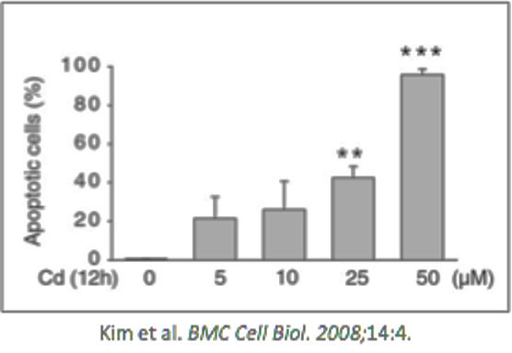

**Figure (2):**

Additionally, we would like to draw attention to the possibility that the method and design of the study might have affected our outcomes. We had to make some decisions in order to modify the design of the interaction from the robot experimental setting so that it would be comparable to that of a human interaction partner. Page 9: Paragraph 5

The discussion section's conclusion and future directions ought to be included in this. You can include any new research questions that came up as a result of your study in this section. This paragraph should also discuss the field's implications of your findings.

When writing the results and discussion sections, researchers frequently make a number of mistakes. You can avoid making these common errors by following the checklist below.

* Your results section should not contain any interpretations or explanations of the findings. Keep in mind that the reader will learn what you found in the results section and what it means and why it matters in the discussion section.
* Negative findings should not be left out of your results section. Negative findings are important to other researchers, despite the temptation to report only positive results.
* You should not introduce any findings that were not mentioned in the results section in the discussion section. You should discuss and explain only what you have already reported, and these two sections should be aligned.
* In the discussion paper, do not rehash the results without critically examining what they mean and why they are important.
* Make sure that these two sections are aligned and that the flow from the results section to the discussion section is clear by going back.

.CONCLUSION

Time New Roman Font size 10

A conclusion never introduces any new ideas or results. Rather, it provides a concise summary of those which have already been presented in the report. When writing a conclusion you should:

• briefly restate the purpose of the experiment (i.e. the question it was seeking to answer)

• identify the main findings (i.e. the answer to the research question)

• note the main limitations that are relevant to the interpretation of the results

• summarise what the experiment has contributed to the broader understanding of the problem..

REFERENCES

***--------------------------------------------------------***

Time New Roman Font size 10

A reference list is a complete list of references used in a piece of writing including the author name, date of publication, title and more. An APA reference list must:

* Be on a new page at the end of the document
* Be alphabetically by name of first author (or title if the author isn’t known, in this case a, an and the should be ignored)
* If there are multiple works by the same author these are ordered by date, if the works are in the same year they are ordered alphabetically by the title and are allocated a letter (a,b,c etc) after the date
* Contain full references for all in-text references used

Ackery, P. R., Smith, C., & Vane-Wright, R. (1995). Carcasson's african butterflies: An annotated catalogue of the papilionoidea and hesperioidea of the afrotropical region CSIRO PUBLISHING.

Andren, H., 1994. Effects of habitat fragmentation on birds and mammals in landscapes with different proportions of suitable habitat: a review. Oikos, pp.355-366.

Atauri, J. A., & de Lucio, J. V. (2001). The role of landscape structure in species richness distribution of birds, amphibians, reptiles and lepidopterans in mediterranean landscapes. *Landscape Ecology, 16*(2), 147-159.

Bell, S. S., McCoy, E. D., & Mushinsky, H. R. (2012). *Habitat structure: The physical arrangement of objects in space* Springer Science & Business Media.

Bergman, K., & Landin, J. (2002). Population structure and movements of a threatened butterfly (lopinga achine) in a fragmented landscape in sweden. *Biological Conservation, 108*(3), 361-369.

Cranston, P. J. G. (2010). *The insects: An outline of entomology/Penny J. gullan, peter S. cranston.*

Fox, R., Parsons, M., Chapman, J., Woiwod, I., Warren, M., & Brooks, D. (2013). The state of Britain’s larger moths 2013. *Butterfly Conservation and Rothamsted Research, Wareham, Dorset, UK,*

Gadhikar, Y., Sambath, S., & Yattoo, I. (2015). A preliminary report on the moths (insecta: Lepidoptera: Heterocera) fauna from amravati, maharashtra. *International Journal of Science and Research, 4*(7), 883-887.

Kitching, R., Orr, A., Thalib, L., Mitchell, H., Hopkins, M. S., & Graham, A. W. (2000). Moth assemblages as indicators of environmental quality in remnants of upland australian rain forest. *Journal of Applied Ecology, 37*(2), 284-297.

Larsen, T. H., Williams, N. M., & Kremen, C. (2005). Extinction order and altered community structure rapidly disrupt ecosystem functioning. *Ecology Letters, 8*(5), 538-547.

Muirhead-Thomson, R. (1991). Plant pest responses to visual and olfactory ‘sticky’traps. *Trap Responses of Flying Insects.Academic, CA,* , 180-196.